Exercise 17
- Find and list the ids and spouse names of all employees who are married.
SELECT id, spouse FROM employee_data WHERE spouse is not null and TRIM(spouse) != "";
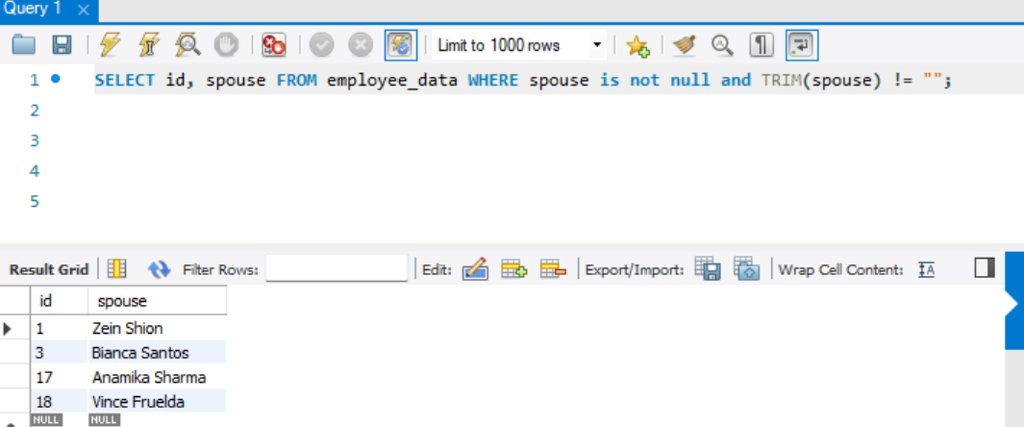
- Change the above so that the display is sorted on spouse names.
SELECT id, spouse FROM employee_data WHERE spouse is not null and TRIM(spouse) != "" ORDER BY spouse;
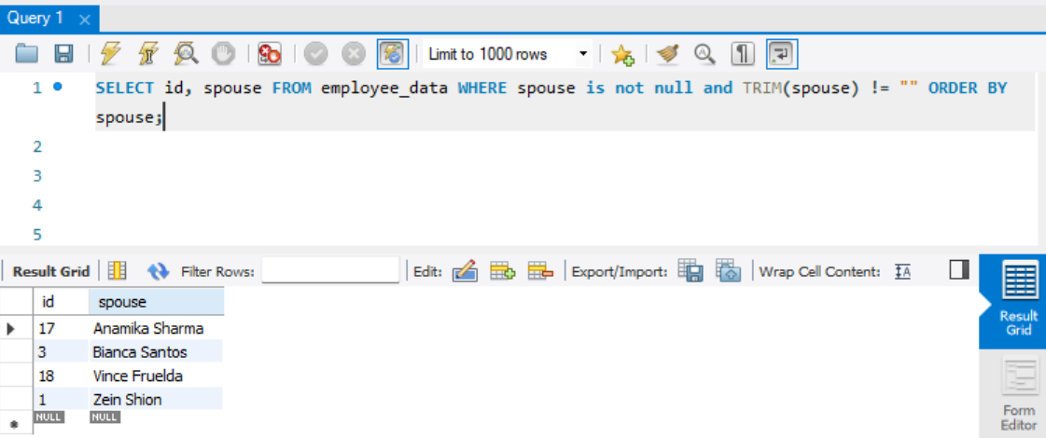
- How many employees do we have under each(male and female)
SELECT sex, count(id) as count FROM employee_data GROUP BY sex;
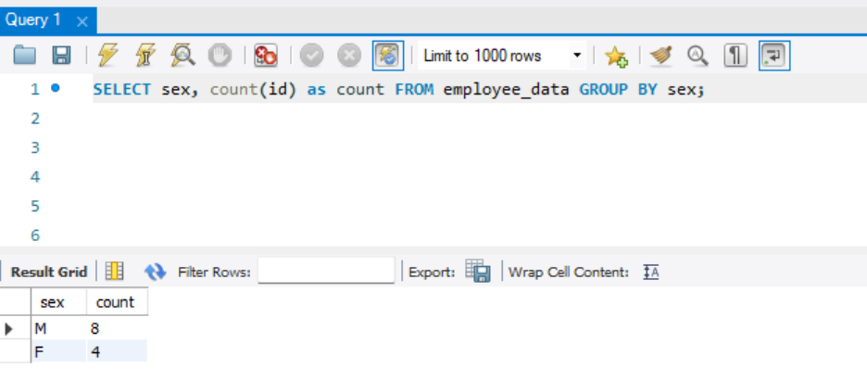

- How many of our employees are married and unmarried.
SELECT (SELECT count(spouse) FROM employee_data WHERE spouse is not null and TRIM(spouse) != "") as married, (SELECT count(spouse) FROM employee_data WHERE spouse is null or TRIM(spouse) = "") as not_married;
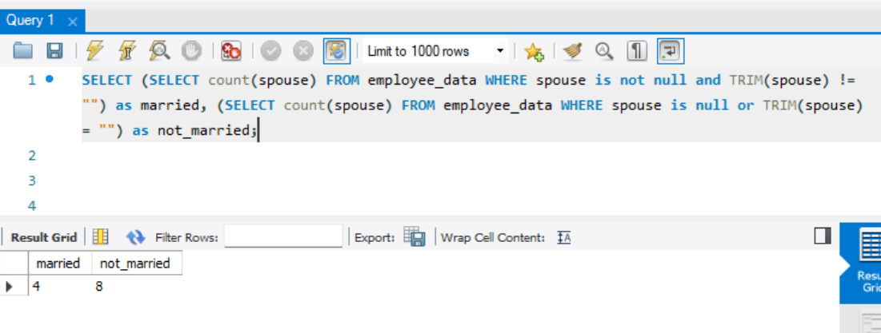
- Find the total number of children.
SELECT sum(children) as total_children from employee_data;
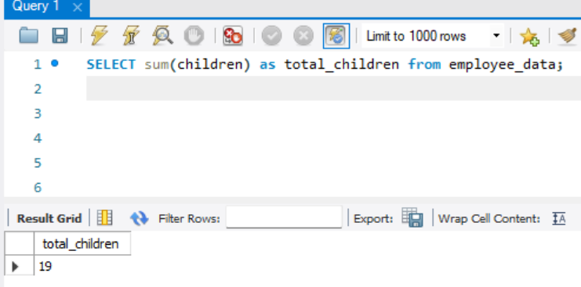
- Make unique groups of children and find the number in each group. Sort the display with the group having maximum children, at the top.
SELECT sum(children) as total_children from employee_data GROUP BY id ORDER BY total_children DESC;
